How to Identify Status of Concur Submissions
During fiscal year end, it will be very important for users to know where reports (expenses and pcard statements) submitted for payment are in the approval workflow in Concur.
- For FY24 expenses submitted in Concur, reports must be through all approvals by 5:00pm CST, 6/7/24.
Required approvals include:
- Special approvals (IT, Project)
- Human Resources Supervisor
- Financial Approver (Cost Object)
It is the department’s responsibility to ensure all approvals are obtained to meet the above deadline.
In order to help identify where reports are in the approval workflow, Concur users can review their submitted Expenses from the Manage Expenses page in Expense.

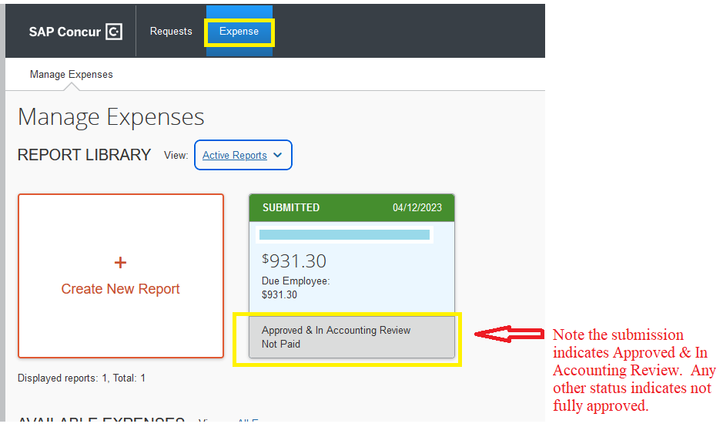

Reach out to approvers and request their approval. Review the Audit Trail to identify who needs to approve:
